Antibiotic resistance – how does it work?

What are antibiotics?
Antibiotics are medicines that can kill or inhibit the growth of bacteria, and therefore can cure infections in people and animals. Antibiotics are medicines for bacterial infections (such as pneumonia or bloodstream infections), rather than viral infections. Not all antibiotics are active against all bacteria – some are effective against only one bacteria, some work for multiple bacteria.
What is antibiotic resistance?
Bacteria are “antibiotic resistant” when specific antibiotics have lost their ability to kill or stop the growth of the bacteria. Some bacteria are naturally resistant to certain antibiotics, but more worryingly, bacteria that are normally susceptible to antibiotics can become resistant.

This happened after bacteria are exposed to antibiotics. Sometimes, one of the bacteria can survive because it found a way to resist the antibiotic. If even one bacterium becomes resistant to antibiotics, it can then multiply and replace all the bacteria that were killed off.

These resistant bacteria which survive the antibiotic can continue to multiply, causing infection or even death, even in other people who have not taken any antibiotics. Infections caused by resistant bacteria are far harder to treat, and doctors often need to try a large number of antibiotics (which may have severe side effects) before finding one that works.

Some bacteria can “neutralize” an antibiotic by changing it in a way that makes it harmless. Others have learned how to pump an antibiotic back outside of the bacteria before it can do any harm. Some bacteria can change their outer structure so the antibiotic has no way to attach to the bacteria it is designed to kill.
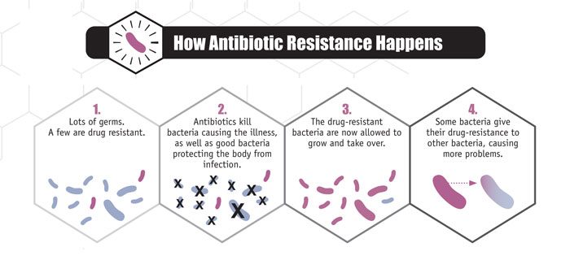

For more information, watch this nine-minute animation explaining how antibiotic resistance emerges and increases among bacteria.

What is the most important cause of antibiotic resistance?
Excessive and inappropriate use of antibiotics encourages the emergence and spread of antibiotic-resistant bacteria. Overuse of antibiotics in human medicine is the main cause of antibiotic resistance in human bacterial infections. However, overuse of antibiotics in farming is also contributing to this problem.

Antibiotic use in food-producing animals – what’s the problem?
Overuse of antibiotics in farm animals is encouraging the emergence of resistant bacteria. These bacteria can the then spread to people: through the meat they handle, through direct contact with animals, or simply through the environment. Sometimes, resistant bacteria that have come from animals can ‘colonise’ a human, but not cause an infection until years later.

This presents a big risk to human health, because many of the antibiotics used to in farming belong to the same class as those used for humans. Even antibiotics which are critically important for people are used in farm animals. This means that bacteria in animals may become resistant to antibiotics which are also used to treat serious human infections.

The problem is not around residues of antibiotics in the food we eat. The problem is that certain resistant bacteria can transferred from animals to humans, meaning that antibiotics no longer work for us.

This is already happening. For some human infections such as Campylobacter or Salmonella, farm antibiotics use is the main cause of resistance in human infections. For E.coli infections, farm antibiotic use contributes significantly. In recent years, MRSA from farm animal origin has become a big problem in people.

We are approaching a post-antibiotic era, where many standard medical treatments will fail, and simple procedures and operations could once again kill.

How do we tackle this problem?
While antibiotic resistance is a natural phenomenon, it is possible to slow and reverse resistance trends. This means dramatically reducing the amount of antibiotics we use.
In farming, the vast majority of antibiotics are given to groups of animals which aren’t even sick. Antibiotics are often given to animals via their feed or water – particularly in the pig and poultry industries. This indiscriminate use of antibiotics must stop if we are to tackle the human antibiotic resistance crisis.
The Alliance to Save our Antibiotics is calling for an EU-wide ban on the routine preventative mass-medication of groups of animals through their feed or water. We are also calling for dramatic reductions in farm use of antibiotics classed as ‘critically important’ for humans. Crucially, we want to see improvements to animal welfare and husbandry, and a shift towards higher welfare systems which reduce the need for antibiotics in the first place.

